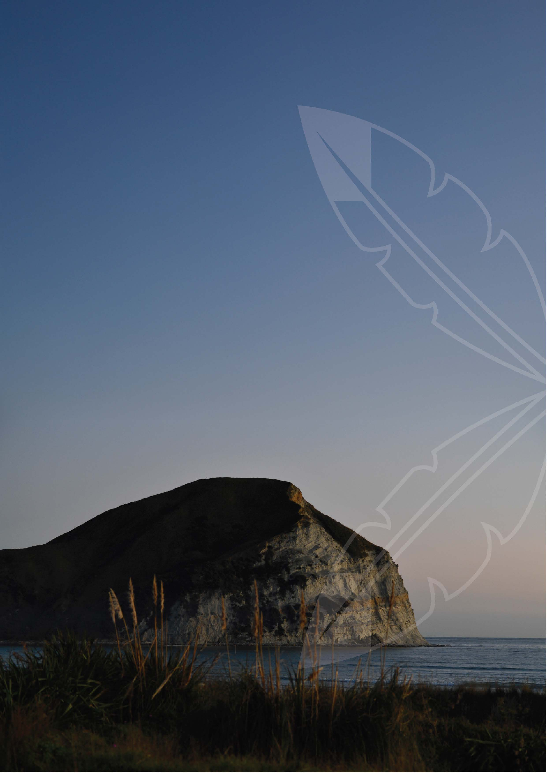
Rongomaiwahine Iwi Trust Group
Pūrongo ā-Tau 2024-25
Annual Report 2024-25
(Year ended 30 June 2025)

Contents
Directory 3
Officers 3
Rongomaiwahine Iwi Trust Board Members & Marae Affiliation 4
Marae Trustee Members 4
Non-Trustee Board Members 5
He Kōrero a te Tiamana | Chair's Message 6
He Whakarāpopotonga a te Kaiwhakahaere Matua | Chief Executive's Overview 8
Tātau Tātau Representative Message 10
Leon Symes, Tātau Tātau Representative 10
Strategic Context 12
Our Year: 2024-25 at a Glance 12
The Engine for Action: How We Delivered 13
Looking Forward: Implementing Our Annual Plan 2025-26 15
Acknowledgements 19

Directory
Rongomaiwahine Iwi Trust, Discretionary Trust, Established: 2018

Rongomaiwahine Iwi Charitable Trust, Charitable Trust, Established: 1988

Officers
Chairperson: Paul Ratapu
CEO: Terence Maru Junior
Board Secretary: Jackie Pirihi
Accountant: Kiwitax, Napier
Auditor: Crombie & Associates, Lower Hutt
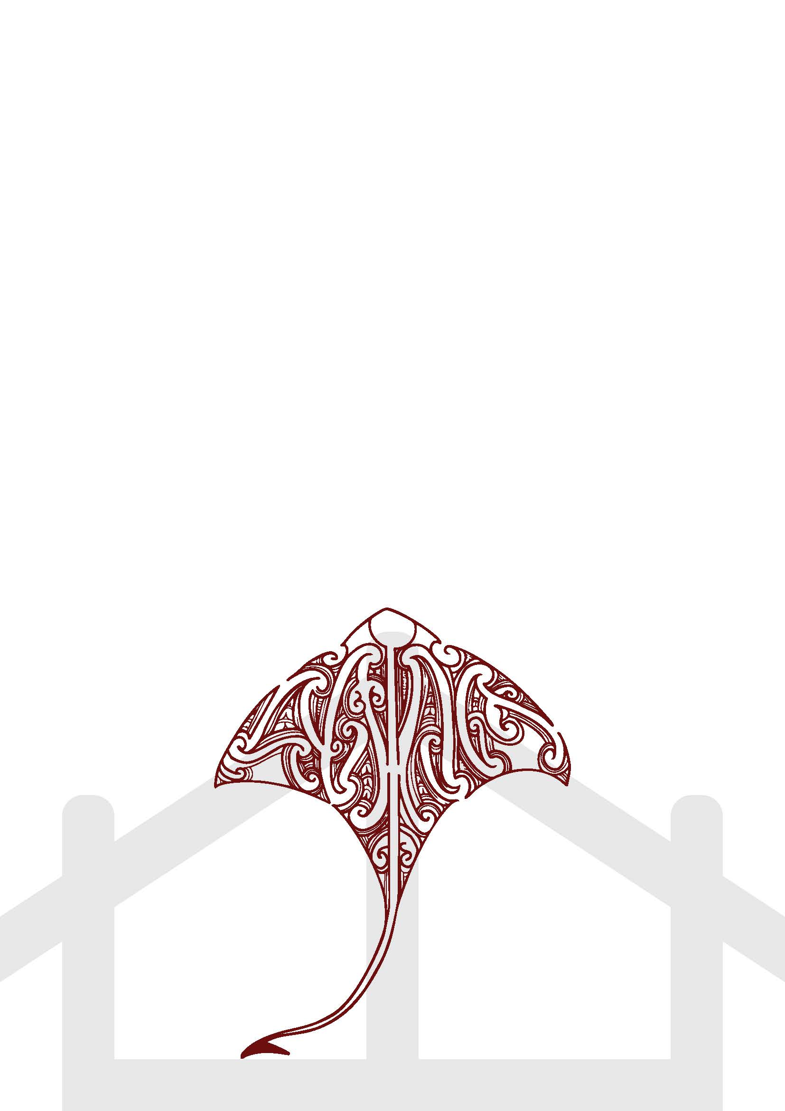
Solicitors: Hockly Legal, Auckland, Whaia Legal, Wellington, Tompkins Wake, Rotorua, Brown & Bates, Napier

Rongomaiwahine Iwi Trust Board Members & Marae Affiliation

Marae Trustee Members
Trustee Name | Marae
Sapphire Cooper (Ahikaa) | Apaapa-ā-Rangi
Elizabeth Palmer | Apaapa-ā-Rangi
Darren Te Rangi (Ahikaa) | Kaiuku
Glenn Webber | Kaiuku
Jody Wahati Rarere (Ahikaa) | Mahanga
Hinepua Morrison | Mahanga
Pikihoro Tuhi (Ahikaa) | Ruawharo
Huia Dyjiak (Ahikaa) | Ruawharo
Fiona Wairau (Ahikaa) | Te Ātihau
Paul Râtapu | Te Ātihau
Kenross Campbell (Ahikaa) | Tuahuru
Stephanie Tibble | Tuahuru
Position Vacant | Te Rakato

Non-Trustee Board Members
Board Member Name | Representing
Leon Symes | Tātau Tātau o Te Wairoa
Bernadette Hamlin | Pakeke
John Andrew | Pakeke

He Kōrero a te Tiamana | Chair's Message
Paul Ratapu, Chairperson
Tēnā koutou katoa,
As we gather to reflect on the year past, we first bow our heads and remember those who have journeyed on. We feel the profound absence of cherished members of our Rongomaiwahine whānau who have passed away this year. Our hearts and aroha remain with their families. The contributions of these loved ones are woven into the fabric of our iwi, and their memories inspire us to continue building a community they would be proud of.
This year has been one of continued governance stewardship. We farewelled former trustee Pania Tyson-Nathan and welcomed new trustee Stephanie Tibble. Our board continues to strengthen with diverse capabilities.
Governance & Strategy
We have taken the initial step of convening a committee to discuss the scope and process for a future constitutional review, ensuring our structures serve our iwi's future needs. This includes planning for new entities and streamlining operational processes. We were in the final stages of progressing the handover of our YMCA asset, with completion expected shortly after the end of the financial year.
Treaty Settlement & MACA
Our Rongomaiwahine Iwi Trust (RIT) has maintained its position on our Treaty settlement interests, including Takutaimoana (MACA) negotiations and Deffered Settlement Property (DSP) discussions with LINZ. These complex processes have faced Crown-driven delays. We acknowledge the frustration this causes and want to assure our beneficiaries that we remain committed to securing the best outcomes and will be prepared to advance these matters as clear pathways emerge.
Financial Stewardship
We celebrate the outstanding performance of Tātau Tātau o Te Wairoa, in which RIT is a beneficiary. The value of the KBUs has seen substantial growth, increasing from $1.3303 to $1.4879, which has lifted Tātau Tātau total net assets to approximately $149.4 million. This performance by Tātau Tātau contributes to a strong foundation for our iwi's future financial resilience.
My deepest gratitude goes to our Chief Executive, Terence Maru, all our Pou (leaders), and every single kaimahi. Their passion and unwavering commitment are the engine of our success. I also extend my thanks to my fellow Trustees for their wise stewardship, and to you, our whānau, for your trust and partnership.
We enter the coming year with clear priorities and a plan to build on this foundation. The path we are on is deliberate, and our resolve is clear. Together, we will continue to seize every opportunity for the benefit of Rongomaiwahine.
Kia kaha, kia māia, kia manawanui.

Paul Ratapu
Chairperson
Rongomaiwahine Iwi Trust Group


He Whakarāpopotonga a te Kaiwhakahaere Matua | Chief Executive's Overview
Terence Maru, Chief Executive
Tēnā koutou katoa,
This Annual Report for the year ending 30 June 2025 stands as a testament to the profound commitment of our kaimahi and the strength of our partnerships. It is my privilege to present a year of solid, measurable progress for Rongomaiwahine Iwi Trust Group, where we have delivered tangible outcomes that directly benefit our people, guided by our strategic Pou.
POU: MANAAKI – Caring for Our Whānau in Action
Our value of caring was embedded into action, resulting in strengthened whānau resilience. We placed 18 of our rangatahi into steady employment and secured 2 cadetships, building a strong foundation for their futures. Our focus on wellbeing saw us facilitate 110 immunisations, deliver 18 outreach wānanga, and support 15 whānau through the Māori Land Court process, ensuring our community was supported, informed, and resilient.
POU: MANA WHENUA / MANA MOANA – Stewarding Our Lands and Waters
We actively exercised our kaitiakitanga across 1,700 hectares of whenua through our pest control programme. A draft Māhia Freshwater Plan was presented to the Board for feedback. We are now working through that feedback to finalize a plan.
POU: WHAKAPAPA – Weaving Our Identity Together
We strengthened the connections that bind us as Rongomaiwahine. This was achieved by contributing to a community sporting organisation to support a vibrant community hub, a project that has already brought together over 20 whānau. We supported marae resilience and operations through strategic disbursements, empowering them as the heart of our communities.
POU: MĀTAURANGA – Revitalising Our Knowledge
We provided mātauranga disbursements to our marae, enabling them to support cultural transmission and projects based on their local priorities. We delivered 18 outreach wānanga to the wider community. We have focused on developing a strong Māori language foundation with 10 wānanga for 15 tauira. We are also in the active development phase of an educational resource, which we anticipate completing in the coming months to share with all whānau.
Behind every one of these numbers is the unwavering conviction of our kaimahi. Their work is driven by a deep-seated belief in our kaupapa and a shared determination to see our iwi not only succeed but thrive.
These achievements were accomplished while carefully managing our resources and navigating a challenging funding landscape, and they provide a powerful platform for the ambitious work outlined in our 2025-26 Annual Plan.
None of this would be possible without the unwavering support of our whānau, the commitment of our partners, and the sheer determination of our team. I am deeply proud of what we have accomplished together as we continue to bring the vision of He Mahere Rautaki to life.
Ngā mihi maioha,
Terence Maru
Chief Executive
Rongomaiwahine Iwi Trust Group

Tātau Tātau Representative Message

Leon Symes, Tātau Tātau Representative

Tēnā Koutou Katoa
It is with great pleasure that I present Tātau Tātau o Te Wairoa Kāhui Representative Report for Rongomaiwahine Iwi for year ending 2025. I would like to start by firstly acknowledging those who have lost loved ones, may they always remain present with us forever. This year has been defined by strategic growth and a reinforced commitment to our people. We have made significant progress against our long-term vision while navigating a challenging economic climate, all with the goal of building a self-sustaining and resilient future for our whānau.
The key highlights for Tātau Tātau over the past 12 months include:
1. Flood mitigation and resilience for our Wairoa whānau directly impacted post Cyclone Gabrielle.
2. Pod Accommodation permanency planning underway, with Housing Repairs completed on 43 homes.
3. Review of the Trust Deed completed and Strategic Plan developed into a new 50-year strategic vision.
4. Advocacy continued through submissions on critical legislation within the current political landscape.
5. Government funding for vital infrastructure for Haumako water storage and a new cool store building.
6. 27 houses in the Te Rauā Development built, with 25 tenanted and a further 16 nearing completion.
7. Direct support for our whānau included 81 educational scholarships and community sponsorships.
8. Strengthened our commercial entity, E Tipu, by enhancing skills base by appointing 4 new directors
Also of note where we have specific interest include:
Deferred Selection Properties
Due to unforeseen issues, no properties were able to transfer during the financial year. However, the process to transfer the former YMCA Camp Grounds (valued at $173,000) into RIT ownership was well-advanced at year-end, with completion anticipated imminently. The former Opoutama School with a transfer value of $440,000 is delayed further due to issues around vacant possession, there is an unknown timeframe still on resolution. In terms of the Mahia East Coast Road Forest, this is still in negotiations with a significant difference in tree valuations between valuers. RIT and Tātau Tātau representatives have been firm with LINZ to ensure our position of ensuring that this property should be transferred for the least amount of money that reflects the true economic value for best use going forward.
Eighth Year Kāhui Distribution
With the return of investments in key asset classes rebounding, there has been a further increase in the Kāhui Beneficial Unit value over the past financial year increasing from $1.33 to $1.48. Though this increase needs to be taken into perspective, particularly as key government contracts around housing initiatives have effectively increased the revenue and asset base as these projects are delivered. Continuing to generate cash returns is the biggest challenge, while waiting for local investments into Horticulture come to fruition to deliver the projected cash distributions. Like previous years the amount in the pool for Kāhui distribution has been set by Tātau Tātau Board, this will likely change as the opportunity for Kāhui to exist and become independent is a potentiality.
Finally it has been an honour to represent your collective interest, it has been a privilege to serve our people and I look forward to connecting with whānau at the Tātau Tātau AGM on 13th December 2025 in Wairoa. My sincere thanks to our trustees and all our whānau for your support. Together, we are building a legacy of prosperity and opportunity. I hope to see as many as you as I can in the new year, have a Merry Christmas and a Happy New Year.
Nāku Noa, Nā
Leon Symes (Rongomaiwahine Iwi - Tātau Tātau Representative)

Strategic Context
The 2024-25 year was shaped by a significant shift in the public funding environment, with fewer government contracts available across the sector. Rather than competing for scarce resources or over-extending our organization, we made a strategic decision to align our operational scale with genuine opportunities.
This meant focusing our resources on delivering exceptional outcomes through our most critical projects while maintaining financial sustainability. We chose to operate as a lean, agile organization that could deliver high-impact results and position ourselves to capitalize on new opportunities as they emerge.
This strategic positioning allowed us to:
- Focus on Excellence in fewer, high-impact projects rather than spreading resources thin
- Maintain Financial Sustainability by ensuring our costs matched our secure revenue streams
- Preserve Organizational Capacity to scale when market conditions improve
- Demonstrate Fiscal Responsibility in our stewardship of iwi resources
The results that follow demonstrate how this focused approach delivered meaningful impact for our whānau while building a resilient organization capable of weathering market fluctuations.

Our Year: 2024-25 at a Glance
Our work in 2024-25 delivered positive outcomes across all areas of our strategy for our 1,884 eligible iwi members. The table below summarises our key areas of achievement.
Area of Focus | Summary of Achievements
Whānau Wellbeing | Successfully supported community health and resilience through immunisation outreach, wellness wānanga, and direct access to hauora and social services.
Rangatahi & Employment | Created concrete pathways through employment, cadetships, and education, investing in the future of our people and growing our internal capability.
Whenua & Moana | Protected and enhanced our environment through large-scale predator control, native planting, freshwater planning, and building community readiness.
Culture & Education | Preserved and revitalised our mātauranga through the creation of lasting educational taonga and cultural development programmes.
Community Infrastructure | Enhanced community assets and sustainability through key facility upgrades and the installation of renewable energy systems.
The detailed performance data for these outcomes is available in our Statement of Service Performance.

The Engine for Action: How We Delivered
Behind every achievement is the work to build the robust engine of our strategic Poutama. This year, we focused on strengthening the five key areas that enable all our work for our people.
1. Embedding Our Pou in Decision-Making
We continue to develop frameworks to ensure our foundational Pou guide our significant project planning and operational decisions.
This ongoing work ensures our actions remain in strategic and cultural alignment with the aspirations of our whānau.
2. Organising to Deliver with Accountability
We maintained strong reporting and accountability to our partners and whānau, submitting all milestone reports on time.
To enhance our financial stewardship, we have partnered with the accounting firm Te Kākano. This partnership is already providing improved financial reporting and insights ensuring greater clarity and accountability for our whānau.
3. Progressing the Security of Our Assets
We actively advanced the return of our Deferred Selection Properties (DSPs), a key priority for securing our settlement assets.
Our diverse funding base, managing contracts with over 15 different government and funding partners, demonstrates our ability to secure and deliver on resources trusted to us.
4. Working the Rongomaiwahine Way (Working Smart)
Our dedicated kaimahi were driven by a deep conviction in our kaupapa, ensuring community-led projects incorporated mātauranga Māori and tikanga.
We empowered our marae through direct mātauranga disbursements.
5. Building Future Capability for a Constrained Environment
In a period of constrained government contracting, we have focused our resources on an agile operational model.
A key strategic priority has been the development of an asset holding entity. This entity is being designed to bring robust commercial expertise to our asset portfolio, building the capability to generate sustainable returns for the iwi independent of the fluctuating contract environment.

Looking Forward: Implementing Our Annual Plan 2025-26
The tangible results we delivered in 2024-25 provide a proven foundation for the ambitious work outlined in our Annual Plan 2025-26. Our primary focus for the coming year is to deepen our understanding of whānau aspirations, ensuring all our work is directly guided by the needs and priorities of our people.
2024-25 Foundation | 2025-26 Priority Project & Deliverable
Built trusted relationships through health outreach, wānanga, and community partnerships. | Whānau Engagement  Systematically understand whānau aspirations by developing 100 Hauora, Rangatahi, Housing, and Resilience Plans to directly inform all RICT projects and strategy.
Placed 18 rangatahi into employment and secured 2 cadetships. | Rangatahi Mentoring  Formalise our support by developing personalised "Rangatahi Development Plans" for 30 youth and launching 2 new rangatahi-led business initiatives.
Managed 1,700 hectares of whenua and completed the Māhia Freshwater Plan. | Nursery Project & Environmental Work  Propagate 1,000 native seedlings for catchment regeneration and establish partnerships with 4 Māori land trusts for planting.
Supported 15 whānau through the Māori Land Court process. | Housing Project  Enable more whānau to build on their whenua by completing detailed housing plans for 25 whānau and supporting 15 whānau through the Māori Land Court.
Provided 110 immunisations and delivered 18 outreach wānanga. | Provide education and navigation support to 30 whānau on immunisation and deliver 6 wānanga on māra kai and rongoā.
Distributed firewood to vulnerable whānau. | Continue to support our most vulnerable by collecting and distributing firewood to 100 whānau.
Partnered with the community to revitalise community gatherings. | Finalise the YMCA solar system, secure a new long-term lessee for Sunset Point, and establish the Asset Holding Entity for commercial expertise.
MACA | Progress our Marine and Coastal Area (MACA) application, building on the successful resolution of interests with Rongomaipapa and determining the most effective pathway to advance our application for the coast from Paritu to the Nuhaka River mouth.
Sunset Point | Secure a new long-term tenant and complete the necessary building upgrades to ensure its long-term success
Acquire our DSPs (YMCA, Opoutama and Mahia Forest) | Finalise the transfer of the YMCA grounds. Continue to progress the transfer of the Opoutama School and the Mahia East Coast Road Forest.
Morere | Continue our kaitiaki role on the Morere Hot Springs Management Committee, supporting the implementation of the culturally-grounded Phase 2 development plan.
Mātauranga Educational Resource | Co-creation of a lasting educational resource that will preserve and share our unique Māhia histories with all whānau for generations to come.
Strengthened governance. | Progress the comprehensive review of our constitutional documents to ensure our governance structures are fit for purpose and effectively serve our iwi's future needs and aspirations.
Strengthening Our Engine: Operational Priorities
To support this focused delivery, we will activate key components of our "Engine for Action":
- Implement the "Pou Decision-Filter" to ensure all significant Trust decisions are guided by our foundational values
- Conduct formal Quarterly Project Reviews to maintain accountability and strategic alignment
- Finalise the Asset Holding Entity to bring robust commercial expertise to our asset development
Activating Paused Projects
The strategic groundwork laid this year positions us to activate currently paused projects as opportunities arise. The completion of the Māhia Freshwater Plan, for example, means we are ready to advance "Te Mana o Te Wai" work as soon as funding allows.
The success of this past year proves our model works. We enter 2025-26 with a clear plan centred on listening to our whānau, and the confidence to build on this solid foundation for the continued benefit of Rongomaiwahine.

Financial Stewardship
The Rongomaiwahine Iwi Trust Group has maintained a position of financial sustainability for the year ended 30 June 2025. Our focus on aligning operational costs with secure revenue has ensured we can continue to deliver high-impact outcomes for our whānau while investing in our future resilience.
The full audited financial statements, which provide a complete record of our financial performance and position, are available upon request.

Acknowledgements
Our achievements this year are a reflection of the collective effort, unwavering support, and shared commitment of many. We extend our deepest gratitude to:
To our Whānau:
Thank you for your participation, trust, and guidance. Your aspirations are the reason for our work and the measure of our success.
To our Kaimahi:
Our heartfelt appreciation goes to every staff member and volunteer. Your profound dedication, hard work, and deep conviction in our kaupapa are the engine behind every achievement in this report.
To our Partners and Funders:
We are grateful for the collaborative relationships with our key partners, including:
- Te Whatu Ora
- Ministry of Social Development
- Department of Conservation
- Ministry for the Environment
- Te Arawhiti
- Wairoa District Council
- Hawkes Bay Regional Council
- Ministry of Education
- Cyclone Gabrielle Appeal Trust
- Eastern and Central Community Trust
- The Tindall Foundation
- World Wide Fund for Nature New Zealand
- Wairoa Young Achiever Trust (He Rau Ringa Wairoa)
- Te Whare Maire O Tapuwae
- Toitu Te Ora
- Te Rau Ora
- And all our other supporting organisations.
To the Rongomaiwahine Iwi Trust Board:
Thank you for your strategic governance, guidance, and steadfast support.
"He rāngai maomao ka taka i tua o Nukutaurua e kore e muri a hokia."
A shoal of fish that passes the reef would not return until another season.
We are committed to seizing this year's opportunities for the benefit of our people.

Rongomaiwahine Iwi Trust
58 YMCA Rd, Mahia, Hawkes Bay
PO Box 9, Mahia 4166
www.rongomaiwahine.iwi.nz

This document was developed with the support of AI tools to enhance our work processes.

